DATA ANALYTICS ASSIGNMENT 2

P.DIVYA

4th B.Tech (CSE) VNITSW 20NN1A0539

DONUT CHART

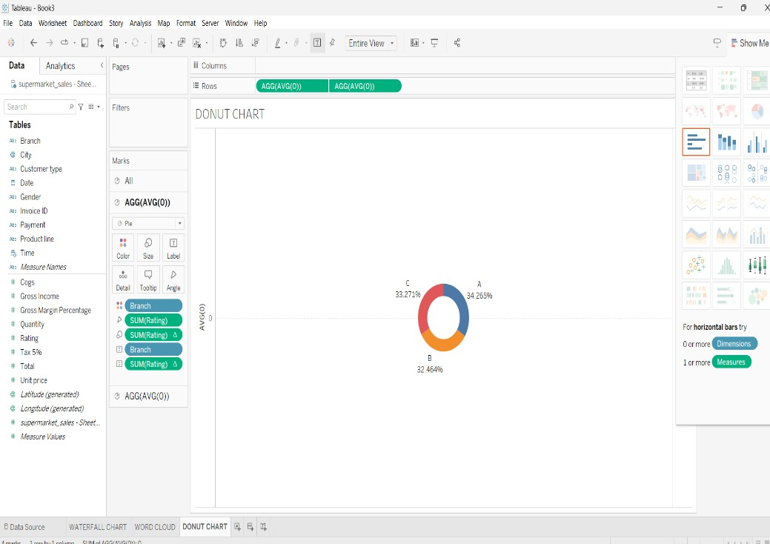

AREA CHART

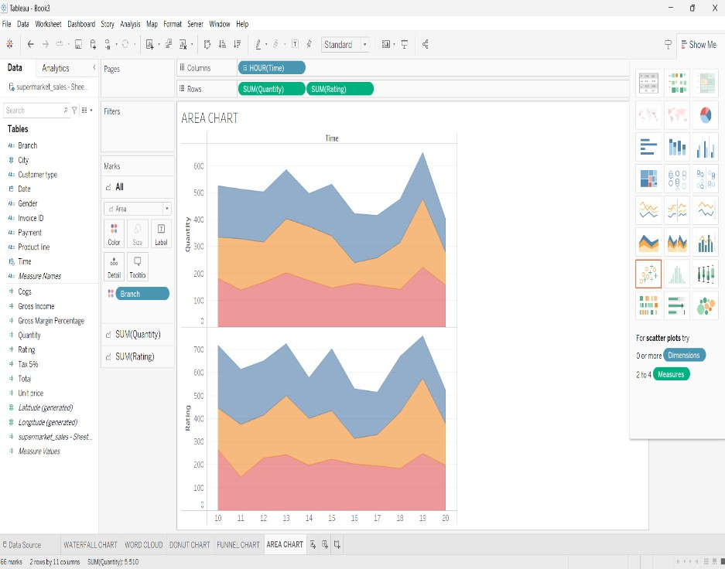

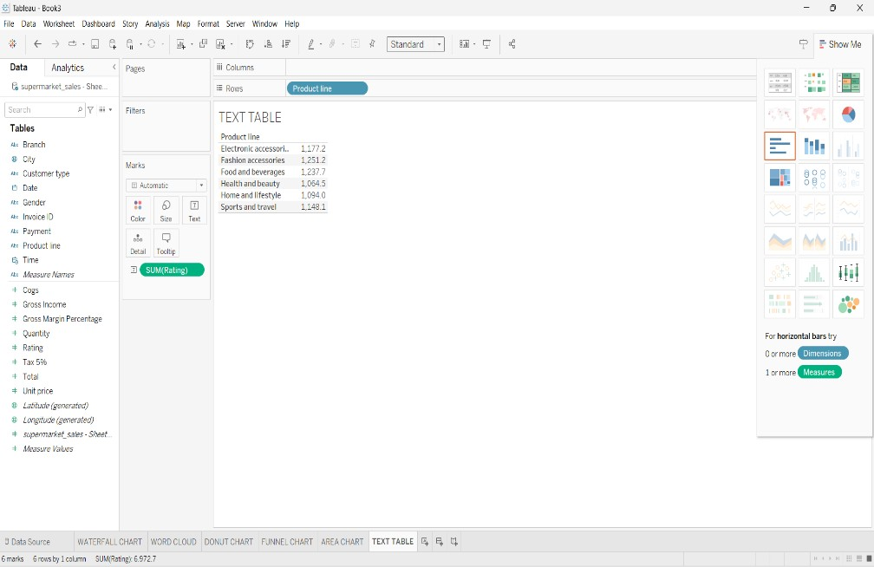TEXT TABLE

HIGHLIGHTED TABLE

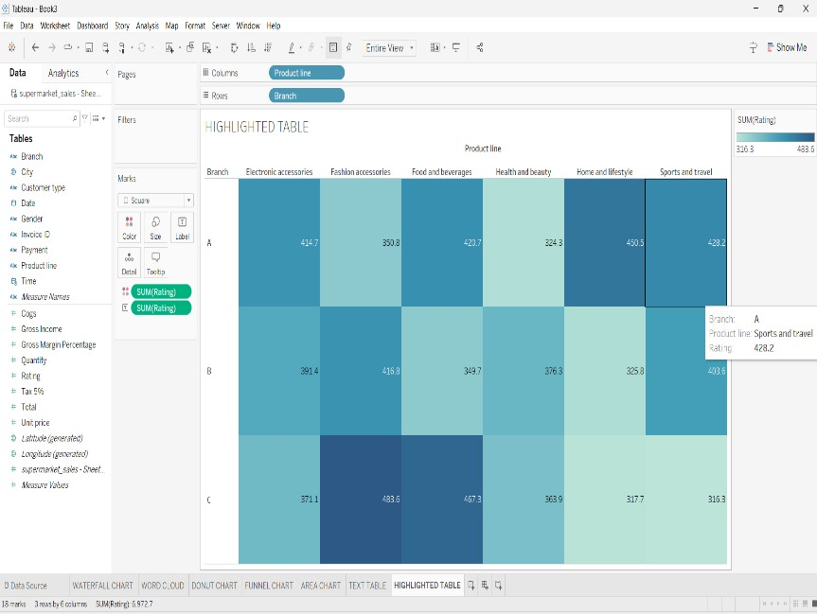

WORD CLOUD

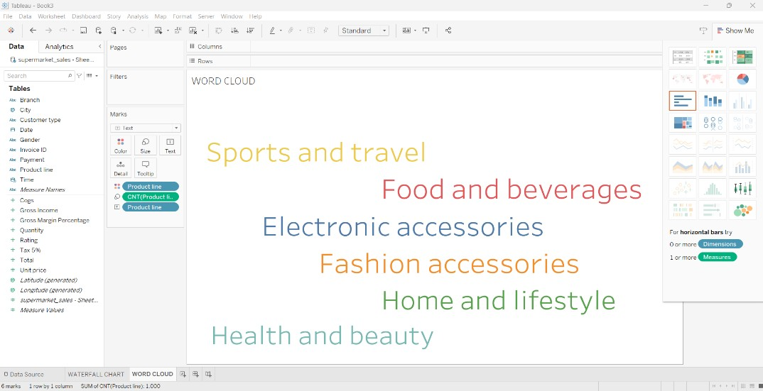

FUNNEL CHART

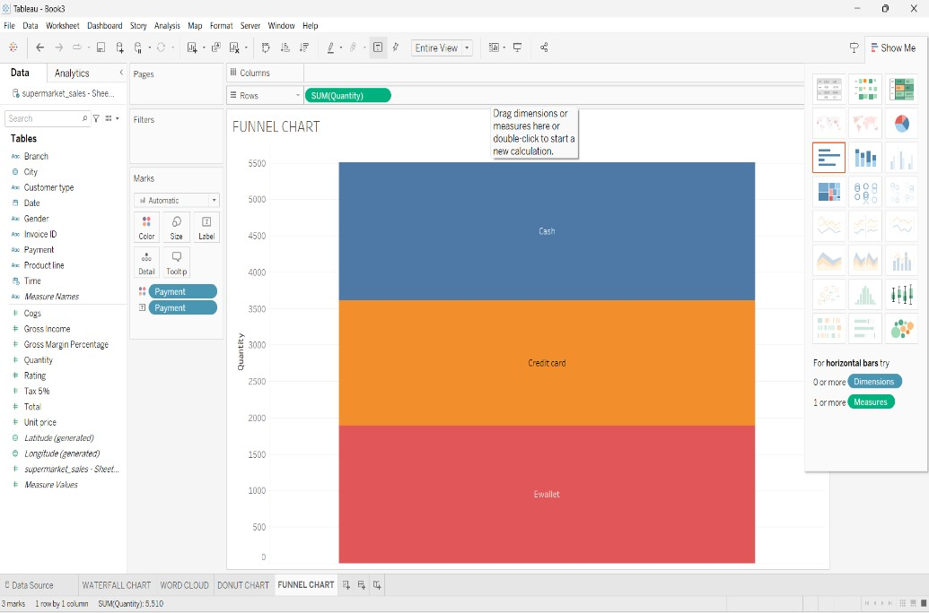

WATERFALL CHART

